Notes Regarding Isolinear Processor:

The RF & LO signals which generate the IF can be at any relative, mathematically stable frequency as shown by the picture:
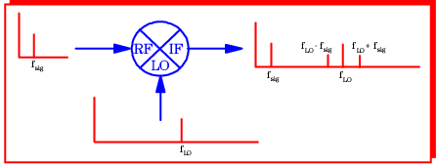

The timing distance between signals f_{LO} and f_{LO} – f_{sig} and f_{LO} + f_{sig} determines the quality of information introduced to the processor as it initially goes through the network and then is shot back once being mixed. f_{LO} is the point of reference for the system, numerous f_{sig} signals can be introduced via pulse patterns to simulate cerebral activity. Distances between signals precursor the output Sydrandria symbol; else, the output number lying between 0 and 4 (see Symbolic Language) and the interpretive alpha-representation.
Geometric representation is given in Intelligent Algorithms.

